Notes
- Among U.S. adults aged 20 and over, 57.6% used any dietary supplement in the past 30 days, and use was higher among women (63.8%) than men (50.8%).
- 3 most common multivitamin-mineral supplements, followed by vitamin D and omega-3 fatty acid supplements.
- Among adults aged 20 and over, 42.4% used none, 22.5% used one, 13.8% used two, 7.5% used three, and 13.8% used four or more dietary supplements in the past 30 days
- 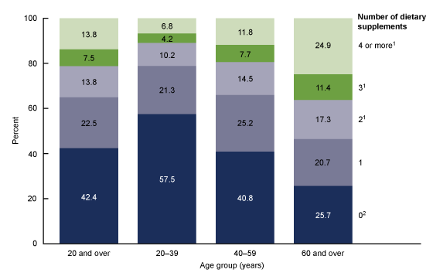
- 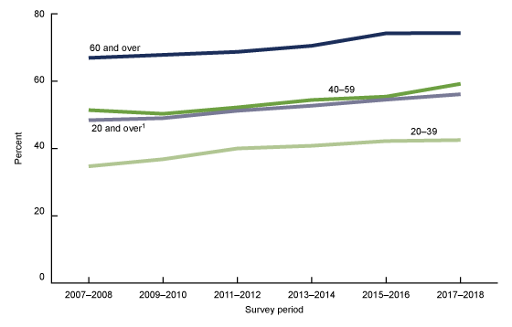
- The prevalence of PFS users in the Dutch population was approximately 10% for men, 17% for women and 13% for children. A wide variety of PFS was used, with around 600 different PFS reported, containing 345 different botanicals. The most frequently used botanicals were echinacea (Echinacea purpurea), ginkgo (Ginkgo biloba), cranberry (Vaccinium macrocarpon), ginseng (Panax ginseng) and algae (such as species belonging to the genus Spirulina or Chlorella).
- From the national food consumption surveys it seems that the percentage of supplement users increases over time; from 17% in 1987/1988 to 27% in 2003
- 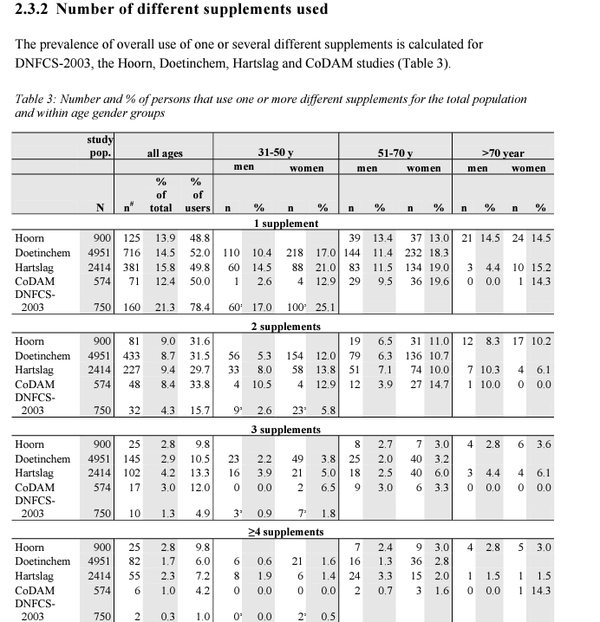
- 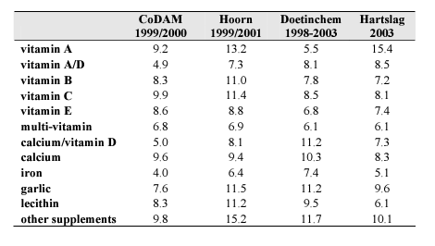

Analysis
The above sources indicate that the number of supplements used increases as consumers age in addition there is a slight trend that the users who take 4 or more supplements tend to stay more consistent throughout various age demographics. This indicates that both of our initial premises for the high-end supplement users are true. In addition, the data show that there is an extremely wide range of supplements that are taken by different users. Because we do not have data on how many use more than four supplements it is essential to have a solid margin of error with the selected slot #. IT should also be considered that the data shows both an increase in use in terms of % of population and also an increase in the number of products used.
Recommendation for slot #
We should use a 5 or 6 slot design as the usage above 4 supplements is highly uncommon even with older consumers. Going above 4 will account for any extreme users, anyone beyond 6 is an outlier that we can address with a future product if the market demands it.
Sources
- https://www.nutraingredients.com/Article/2022/07/12/most-people-in-eu-read-labels-and-take-supplements-safely
- https://pubmed.ncbi.nlm.nih.gov/29184939/
- https://www.rivm.nl/bibliotheek/rapporten/350100001.html
- https://www.fortunebusinessinsights.com/industry-reports/europe-dietary-supplements-market-101918
- https://www.ipsos.com/en/nutrition-pill-europeans-attitudes-towards-food-supplements

- https://foodsupplementseurope.org/who-takes-food-supplements-and-why/
- https://www.cdc.gov/nchs/products/databriefs/db399.htm
- https://www.pennmedicine.org/updates/blogs/health-and-wellness/2020/february/the-truth-about-supplements

